The Fundamental Violence of Physiotherapy
Filip Maric (PhD)

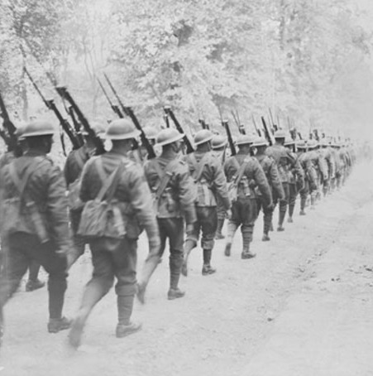

This online session builds on the eponymous article and will discuss ‘The fundamental violence of physiotherapy: Emmanuel Levinas’s critique of ontology and its implications for physiotherapy theory and practice’ (Maric & Nicholls, in review). Ontology and epistemology are generally thought to be the fundamental building blocks of any theory and practice. Levinas’s critique acutely highlights a significant problem that underpins both of these areas of philosophical inquiry and their understanding and positioning as fundamental. Applied to physiotherapy, this critique of ontology and its associated movement of thematisation provides an incisive critique of physiotherapy theory and practice that opens toward a radical rethinking of the profession from its foundations through to its most common, day-to-day assumptions and practices. At a fundamental level, this includes how we understand ourselves as physiotherapy professionals, what we think of as physiotherapy, and how we understand our relation to those that physiotherapy is meant for. We will close the session with a discussion of the central concepts presented and a collaborative exploration of their implications in the different thinking and practice arenas of all participants.

Optional pre-readings:
Maric, F & Nicholls, DA. (in review). The fundamental violence of physiotherapy: Emmanuel Levinas’s critique of ontology and its implications for physiotherapy theory and practice. Open Physio Journal.
Levinas, E. (1985) Ethics and Infinity: Conversations with Philippe Nemo. Duquesne University Press.

